**Student Management Code:**

#include<iostream>

#include<string>

using namespace std;

string name[20],roll_no[20],f_name[20],adrrs[20],mobile_no[20],branch[20];

int total = 0;

void menu(){

    cout<<"\n\t\t*******Student Management System******"<<endl;

    cout<<"\t\t 1. Add Student Details "<<endl;

    cout<<"\t\t 2. Student Data Record "<<endl;

    cout<<"\t\t 3. Search Student "<<endl;

    cout<<"\t\t 4. Update Student data "<<endl;

    cout<<"\t\t 5. Delete Data "<<endl;

    cout<<"\t\t 6. Quit "<<endl;

}

void add()

{

    int s; //variable for number of student

    cout<<"\nEnter the number of student that you want to add in the record  "<<endl;

    cin>>s; //input for number of student

    if(total == 0)//intialising to 0 inoreder to prevent overwriting of same details i.e for same id

    {

    total += s;///total number of the entries that has to be taken from the userend

    for(int i = 0; i < s; i++)

    {

        cout<<"\nEnter the details for student "<<" ID =  "<<i+1<<endl;

        cout<<"Enter Name: "<<endl;

        cin>>name[i];

        cout<<"Roll Number: "<<endl;

        cin>>roll_no[i];

        cout<<"Fathers Name : "<<endl;

        cin>>f_name[i];

        cout<<"Address: "<<endl;

        cin>>adrrs[i];

        cout<<"Mobile Number : "<<endl;

        cin>>mobile_no[i];

        cout<<"Branch: "<<endl;

        cin>>branch[i];

    }

    }

    else{

        for(int i = total; i < total + s; i++)

    {

        cout<<"\nEnter the details for student "<<i+1<<endl;

        cout<<"Enter Name: "<<endl;

        cin>>name[i];

        cout<<"Roll Number: "<<endl;

        cin>>roll_no[i];

        cout<<"Fathers Name : "<<endl;

        cin>>f_name[i];

        cout<<"Address: "<<endl;

        cin>>adrrs[i];

        cout<<"Mobile Number : "<<endl;

        cin>>mobile_no[i];

        cout<<"Branch: "<<endl;

        cin>>branch[i];

    }

    total = total + s;//// to store the previous details and incrementing the total by the number of newly added details

    }

}

void student_record()  //function for displaying the details of the student as record

{

    system("CLS");

    system("color 2");

    cout<<"\n\n\t\t *******Student Data Record******** \n "<<endl;

    for(int i = 0; i <total; i ++)

    {

        cout<<"\nID = "<< i + 1<<"\n"<<endl;

        cout<<"Name : "<<name[i]<<endl;

        cout<<"Roll Number : "<<roll_no[i]<<endl;

        cout<<"Fathers Name : "<<f_name[i]<<endl;

        cout<<"Address : "<<adrrs[i]<<endl;

        cout<<"Mobile Number : "<<mobile_no[i]<<endl;

        cout<<"Branch: " <<branch[i]<<endl;

    }

}

void search()

{

    string roll_number;

    cout<<"Enter the roll number of the given student to be searched "<<endl;

    cin>>roll_number;

    for(int i = 0; i < total; i++)

        {

            if( roll_number == roll_no[i])

            {

                cout<<"\n\n\t\t Details of Student \n\n "<<"ID = "<< i + 1  <<endl;

                cout<<"Name : "<<name[i]<<endl;

                cout<<"Roll Number : "<<roll_no[i]<<endl;

                cout<<"Fathers Name : "<<f_name[i]<<endl;

                cout<<"Address : "<<adrrs[i]<<endl;

                cout<<"Mobile Number : "<<mobile_no[i]<<endl;

                cout<<"Branch: " <<branch[i]<<endl;

                    }

        }

}

void update()

{

    string roll_number;

    cout<<"Enter the roll number of the student which has to be updated "<<endl;

    cin>>roll_number;

    for(int i = 0; i < total; i++)

        {

            if( roll_number == roll_no[i])

            {

                cout<<"\n\n\t\t Previous Details for ID = "<< i + 1 <<" was " <<endl;

                cout<<"Name : "<<name[i]<<endl;

                cout<<"Roll Number : "<<roll_no[i]<<endl;

                cout<<"Fathers Name : "<<f_name[i]<<endl;

                cout<<"Address : "<<adrrs[i]<<endl;

                cout<<"Mobile Number : "<<mobile_no[i]<<endl;

                cout<<"Branch: " <<branch[i]<<endl;

                cout<<"\n\n\t\t Enter New  Details for ID = "<< i + 1<<endl;

                cout<<"Enter Name: "<<endl;

                cin>>name[i];

                cout<<"Roll Number: "<<endl;

                cin>>roll_no[i];

                cout<<"Fathers Name : "<<endl;

                cin>>f_name[i];

                cout<<"Address: "<<endl;

                cin>>adrrs[i];

                cout<<"Mobile Number : "<<endl;

                cin>>mobile_no[i];

                cout<<"Branch: "<<endl;

                cin>>branch[i];

           }

        }

}

void delete_data()

{

    int a;

    cout<<"Press 1 to delete all records Or \nPress 2 delete specific record "<<endl;

    cin>>a;

    if(a == 1)

    {

        total = 0;

        cout<<"All records are removed succcessfully "<<endl;

    }

    else

    {

        string roll_number;

        cout<<"Enter the roll number of the given student that has to be deleted "<<endl;

        cin>>roll_number;

        for(int i = 0; i < total; i++)

        {

                if (roll_number == roll_no[i])

                {

                    for(int j = i; j < total; j++)

                    {

                        name[j] = name[j + 1];

                        roll_no[j] = roll_no[j + 1];

                        f_name[j] = f_name[j + 1];

                        adrrs[j] = adrrs[j + 1];

                        mobile_no[j] = mobile_no[j + 1];

                        branch[j] = branch[j + 1];

                    }

                    total--;

                    cout<<"The require record has been removed successfully...!!"<<endl;

                }

        }

    }

}

main(){

    system("CLS");

    system("color 2");//to add color to the font

    int select; //variable to choose from the menu option

    do{

    menu();

    cin>>select;

    switch(select)

    {

        case 1:

        add();

        break;

        case 2:

        student_record();

        break;

        case 3:

        search();

        break;

        case 4:

        update();

        break;

        case 5:

        delete_data();

        break;

        case 6:

        exit(0);

        break;

        default:

        cout<<"Invalid Input "<<endl;

    }

    }while(1);

}

**Output:**

**Menu**

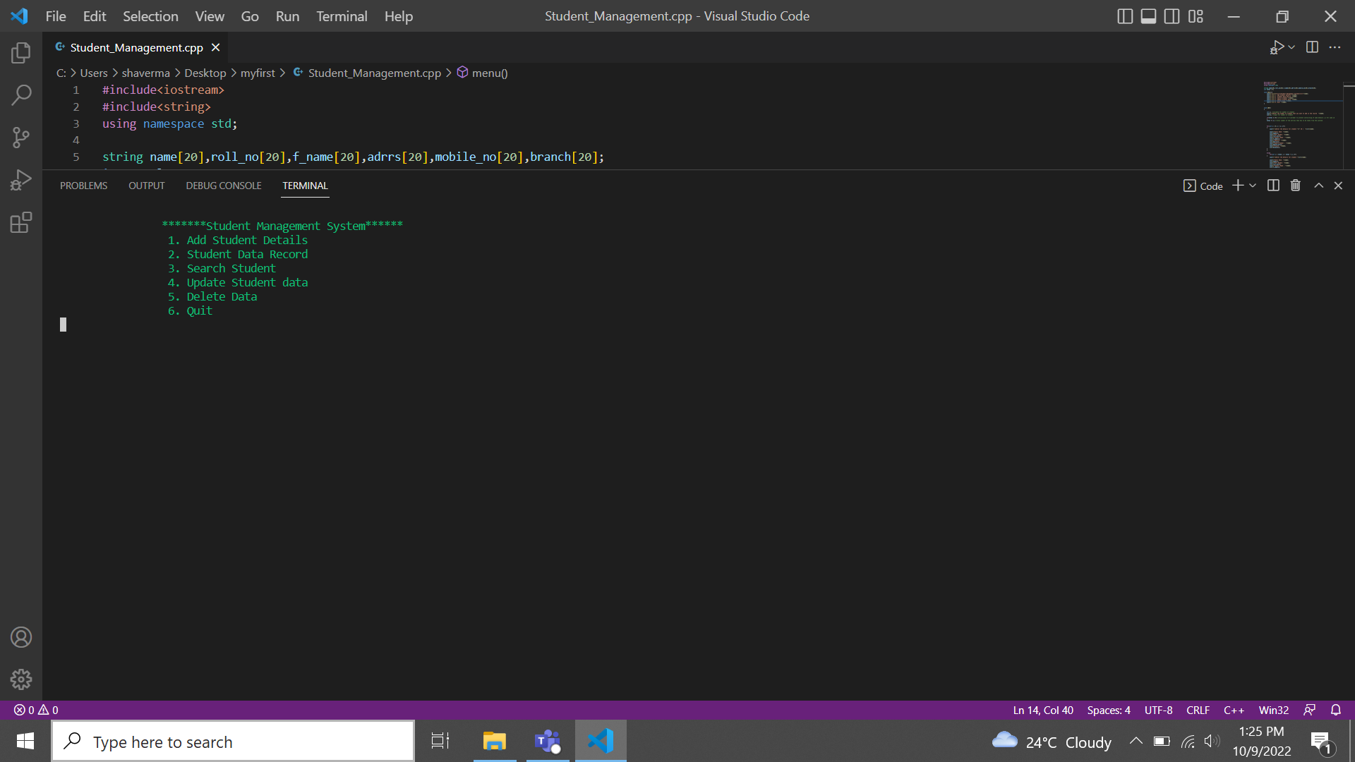

**Adding a student details**

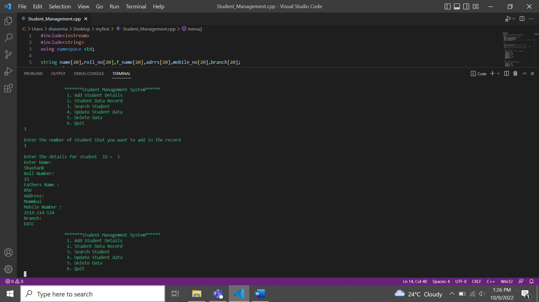

**Displaying the record**

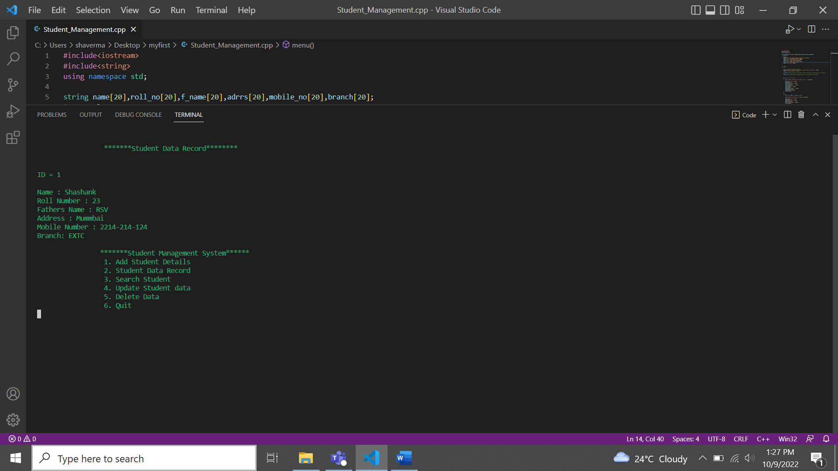

**Adding another entries:**

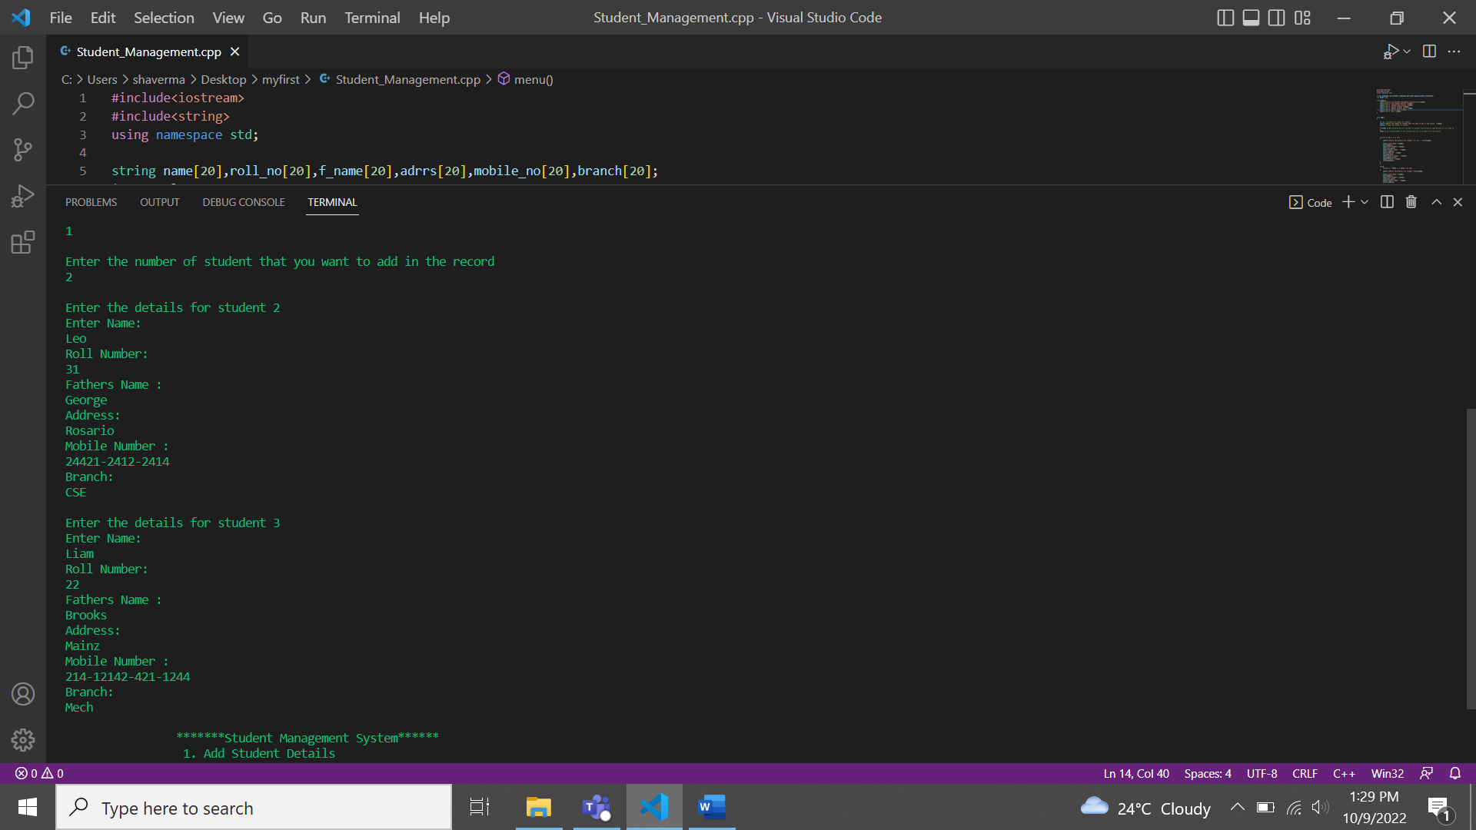

**Displaying the added record**

**Searching a particular student data:**

**Editing or updating the entered data:**

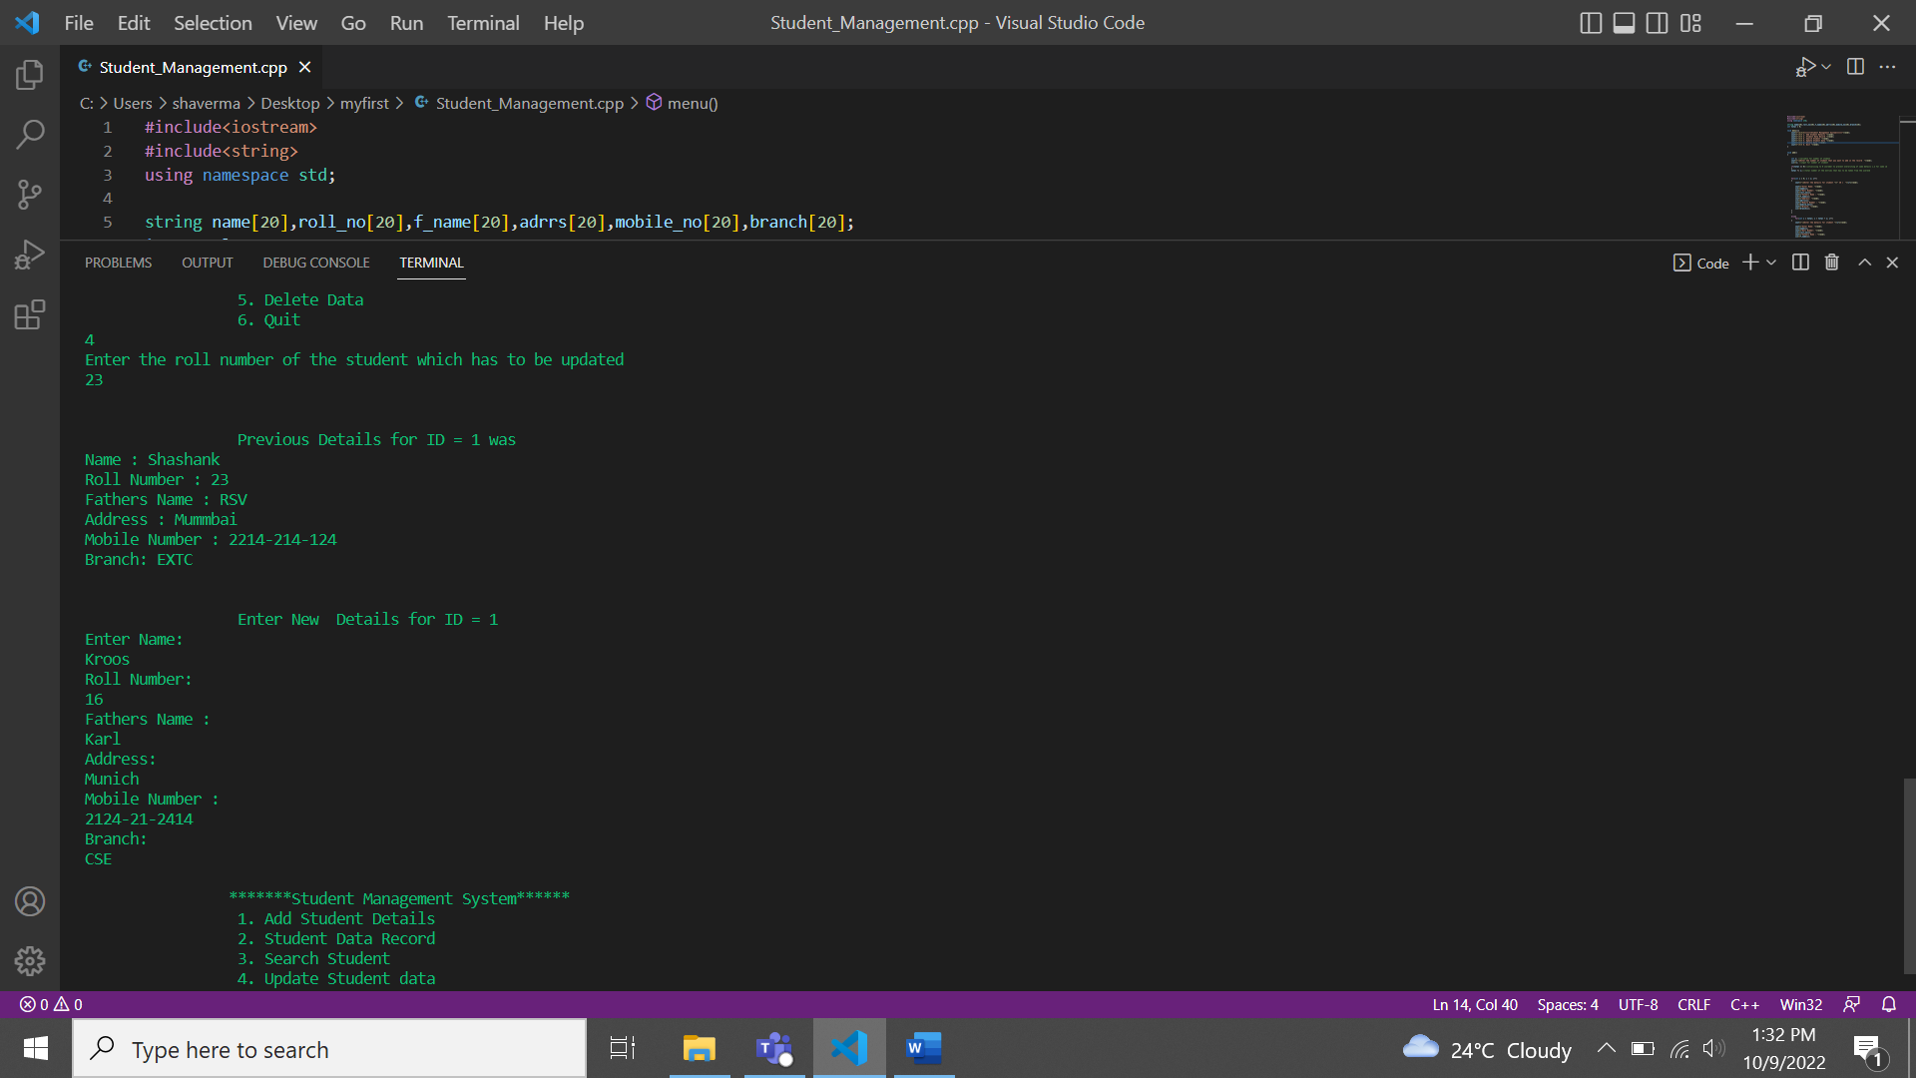

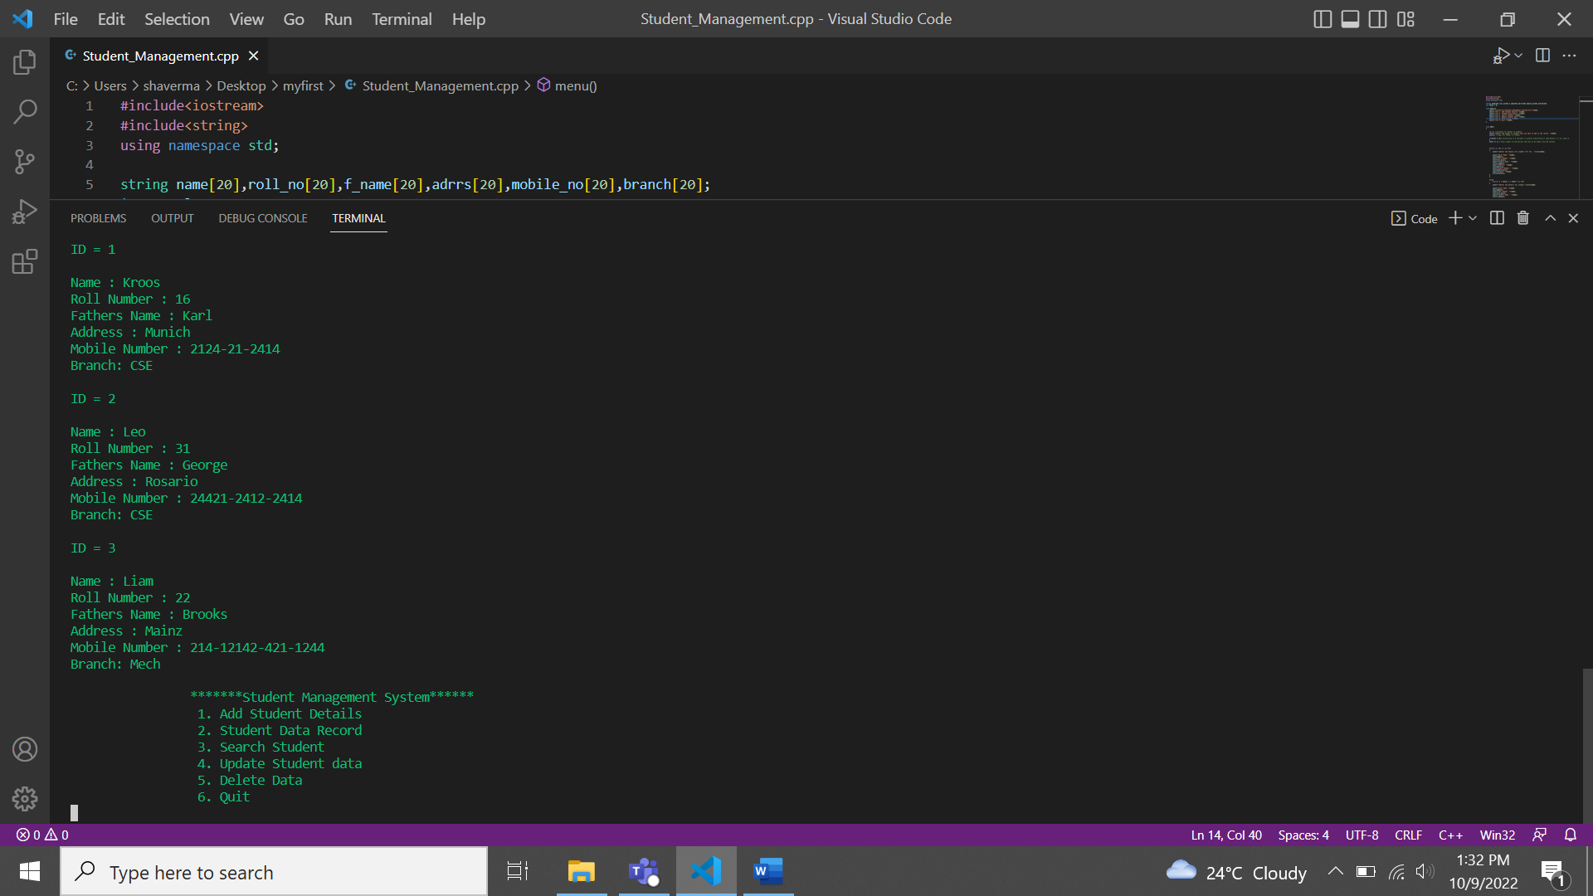

**Deleting the record**

1. **Removing all record at once**

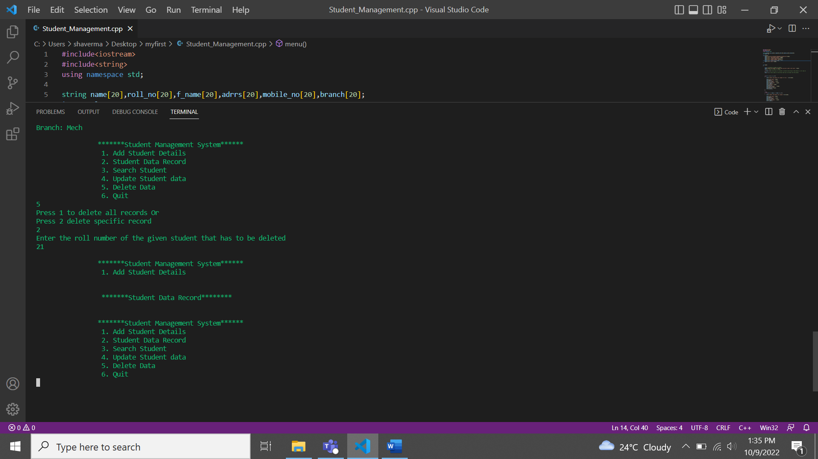

**2.To remove a specific record**



